**[How to use the Import Spreadsheet app](https://sharepoint.rackspace.com/learning/articles/Pages/SharePoint-2013--how-to-use-the-import-spreadsheet-app.aspx)**

1. From the home page of your SharePoint site on the Quick Launch click **Site Contents**.

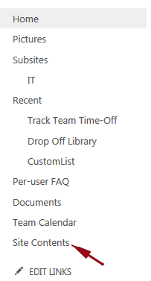

2. On the Site Contents page under List, Libraries, and other Apps click **add an app**.

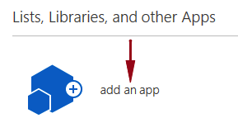

3. On the Your Apps page scroll to the bottom and click the **Next** arrow.

https://sharepoint.rackspace.com/PublishingImages/Pages/sp2013%20how%20to%20use%20the%20import%20spreadsheet%20app/impspreadsheet3.png

4. Scroll to bottom of that page and click **Import Spreadsheet**.

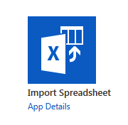

5. In the Name section give it a name, for this example I will call mine “**External Contacts**”.  
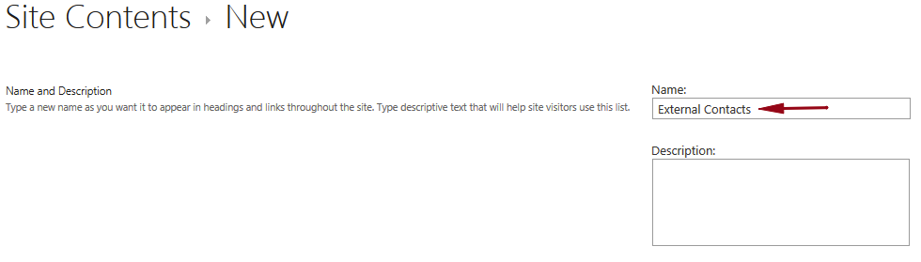

6. In the File location section click **Browse**.

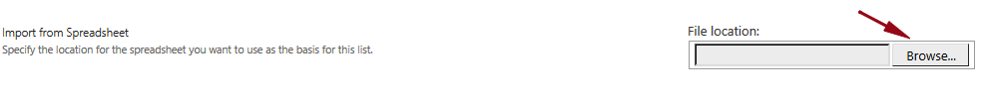

7. Locate the file on your local machine you would like to import, in this example I will import my “**ExtContacts**” spreadsheet.

8. Click **Open**.

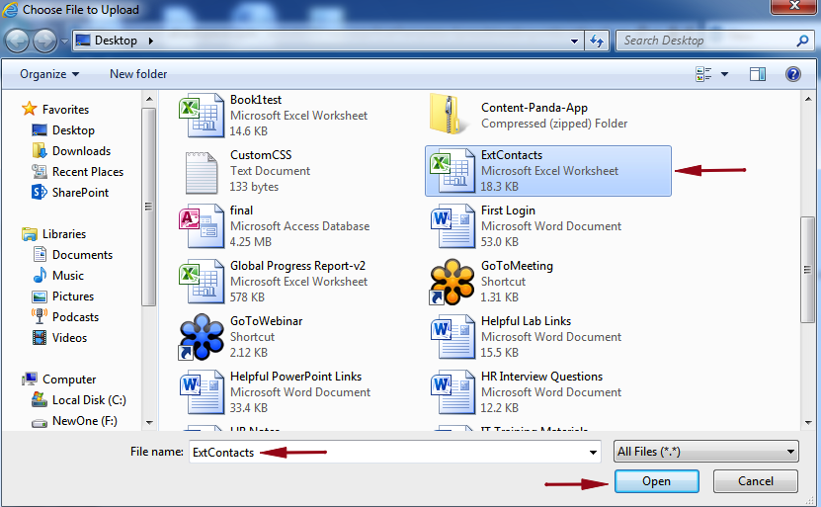

9. Review your settings and click **Import**.

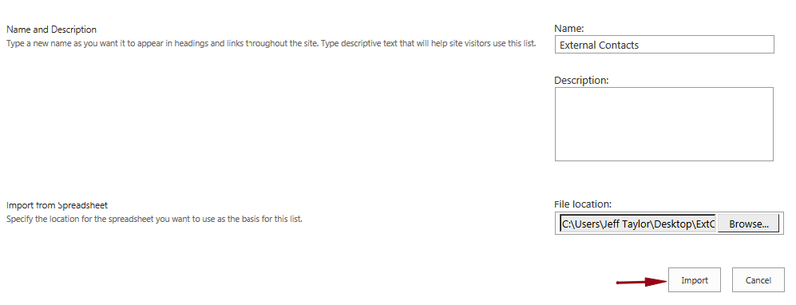

10. Excel will open on your local machine and you may be prompted to enter your username and password. 

11. In the Import to Windows SharePoint Services list pop-up click the drop-down under **Range Type**.

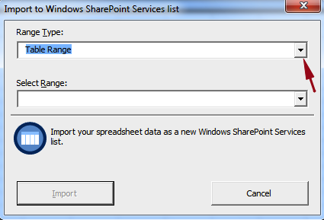

12. From the drop-down select **Range of Cells**.  
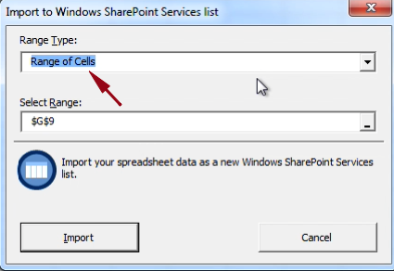

13. In the Select Range section click the “**_**”.

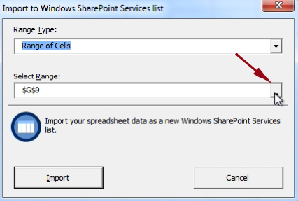

14. Select your range of cells and click the icon to the left of the range.

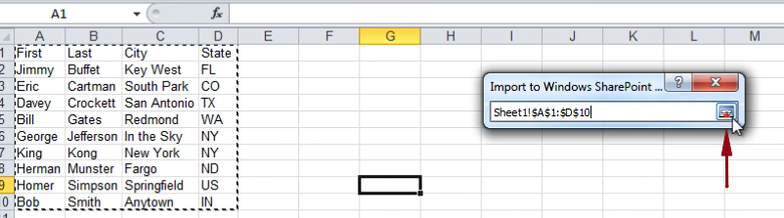

15. You will be taken back to the Import to Windows SharePoint Services list pop-up, review your settings and click **Import**.

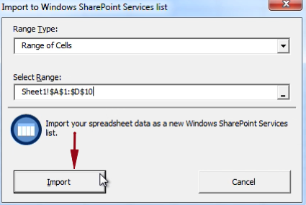

16. Your list will begin exporting from Excel into SharePoint and after a few moments you will see your new “**External Contacts**” SharePoint list.

